Our Club International:

Great news! District has approved our grant application:

Title: Covid Response to Schools and Rural Communities in West Timor and Flores

Background:

What is happening in Indonesia?
- Mortality rates are escalating with Covid Delta.
- Hospitals overwhelmed. People wait outside for a spare bed.
- Shortage of oxygen in Java and Bali.

This ABC news article touched on some of the issues facing Indonesia.

“Australians in Indonesia fear for their safety as deadly Delta COVID outbreak worsens”

https://www.abc.net.au/news/2021-07-10/indonesia-stuck-overseas-helpless-covid-australians-delta/100270898

Also WATCH the video clip within the article:
https://www.youtube.com/watch?v=7Kd4nlI9tiI
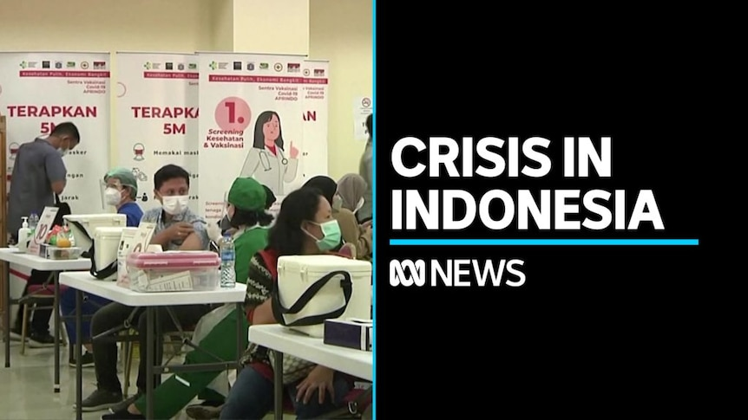

Our support for NTA has even greater significance during this pandemic. The approved District Grant together with our club donation will assist NTA field officers in Flores and West Timor.

The provision of water tanks and toilet/wash units is one of NTA’s most successful programs, greatly improving health and sanitation.

Our 2021-22 Grant projects identified by local NTA staff include:

Support 27 Sikka area families, to each build a water tank to improve hygiene practice.

Covid training: Culturally and age appropriate educational material.
- Print educational posters for Hygine Practice to 500 housholds.
- Covid awareness, sanitation educational packages to 65 schools and 25 key stakeholders. (School principals, Village heads)
- Share information with 100 key stakeholders via WhatsApp groups and distribute electronic files via flash-sticks.
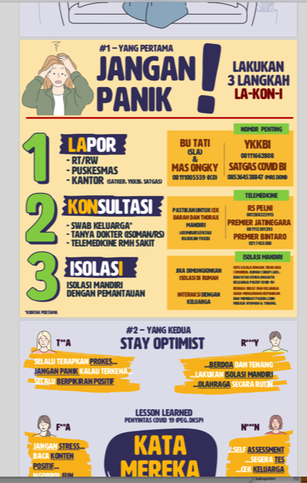 |  | 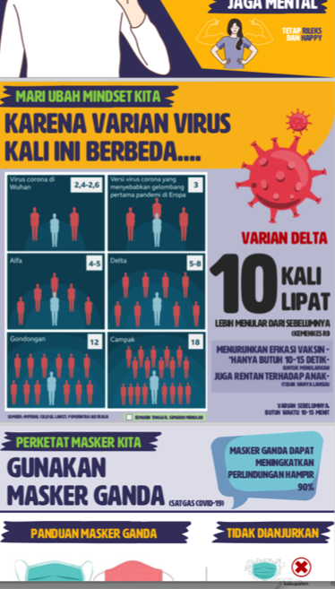
 | 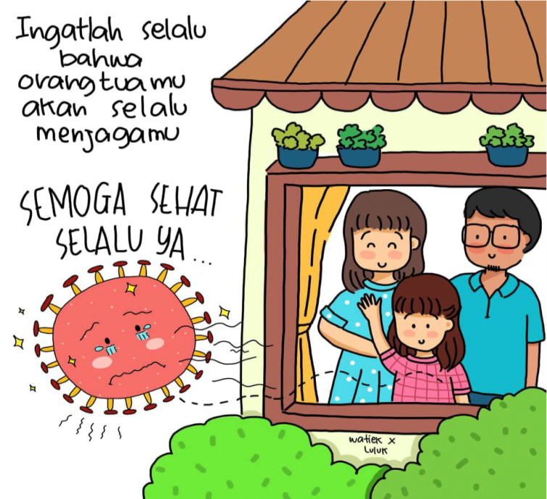

As always, we appreciate our club members’ support for our International NTA program.

