Rotary Club Hunter Valley Getaway 23rd to 26th May 2021
Itinerary

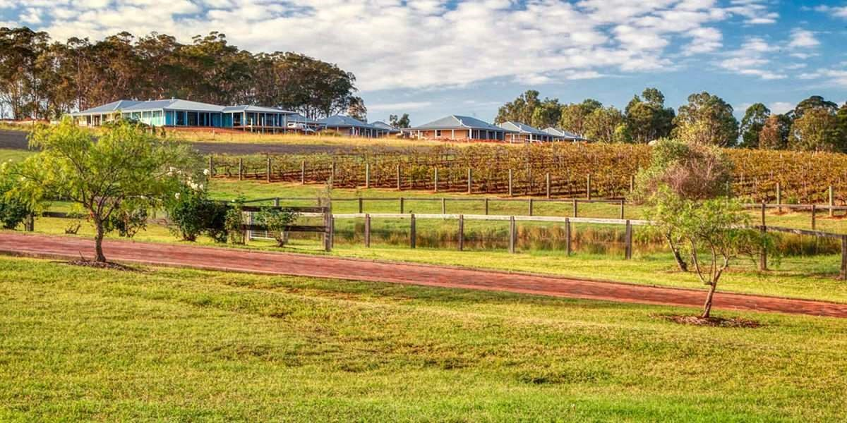

Sunday 23rd May
Travel to Hunter Valley
Lunch en-route
Visitor’s Centre 455 Wine Country Drive Pokolbin
Check in to H Boutique after 2.00PM https://hboutiquehotel.com.au
Free Time
Happy Hour 4.00PM
Dinner -- Il Cacciatore 6.30PM $58 per head set menu olives and focaccia, 2 choices of main and 1 dessert.
https://www.hermitagelodge.com.au/restaurant/

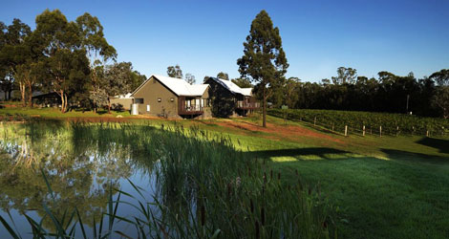

Monday 24th May
Breakfast in Room (Provide own breakfast) or at Café around the area
Morning Activities/Free Time
Lunch own choice
Wine Tour – 2 Fat Blokes – Half Day Snapshot Tour $79 per person

https://twofatblokes.com.au › tours

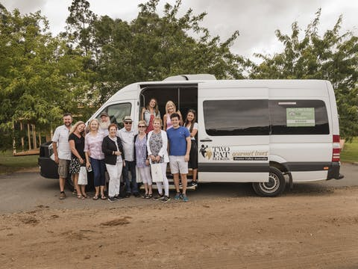
Happy Hour 5.30PM
BBQ Dinner at H Boutique Hotel 7.00PM (Supply own food /drinks)

Tuesday 25th May
Breakfast in Room (Provide own breakfast) or at Café around the area
Optional Activities/Free Time
- Hot Air Balooning
- Golf
- Cycling including electric bikes for the not so fit at Sutton Estate
- Day trip to Maitland and surrounding areas
Lunch own choice
Optional wineries
Happy Hour 4PM
Dinner at Harrigan’s Pub 6.30PM
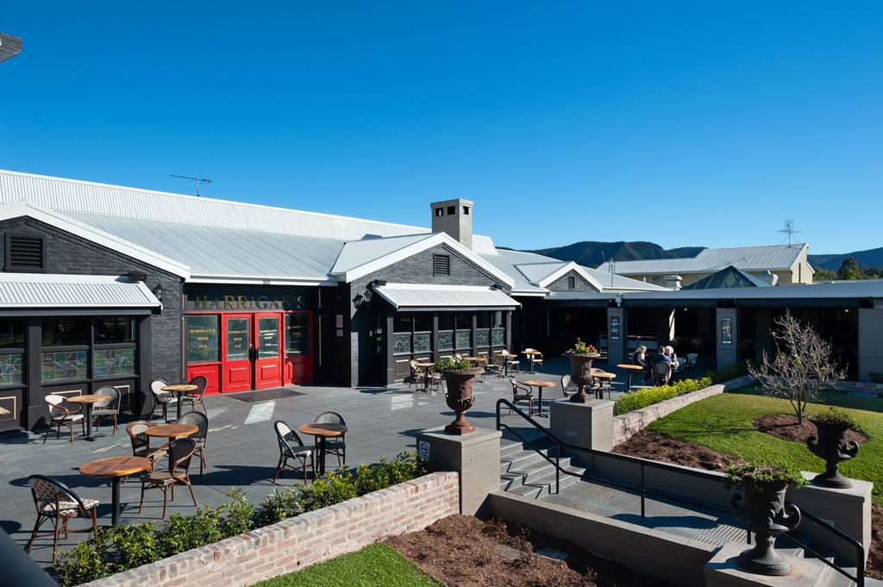
Wednesday 26th May
Breakfast in Room (Provide own breakfast) or at Café around the area
Homeward bound
Lunch or Afternoon Tea en route

Optional Activities

Hot Air Balooning Hunter Valley Gardens

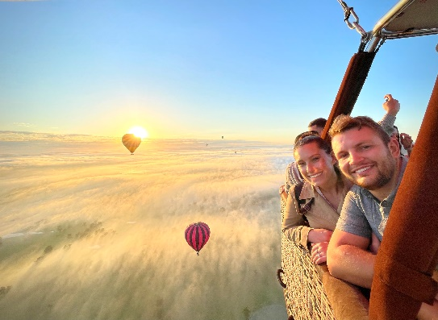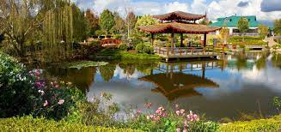

Day Trips to Maitland and surrounding areas
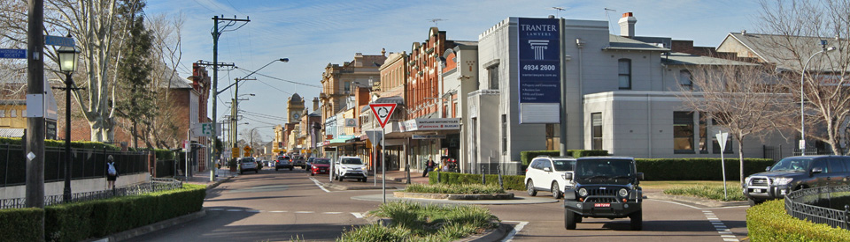

Wineries
- Tyrrels
- Peterson’s Sparkling Wines
- De Iulius
- Thomas Allen

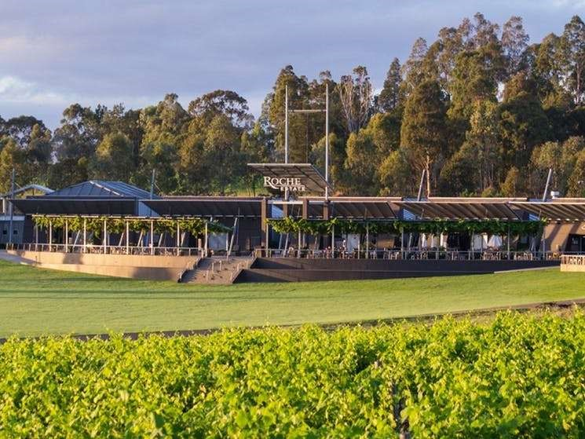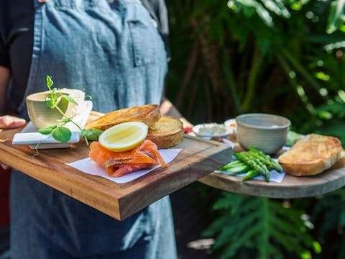

Golf
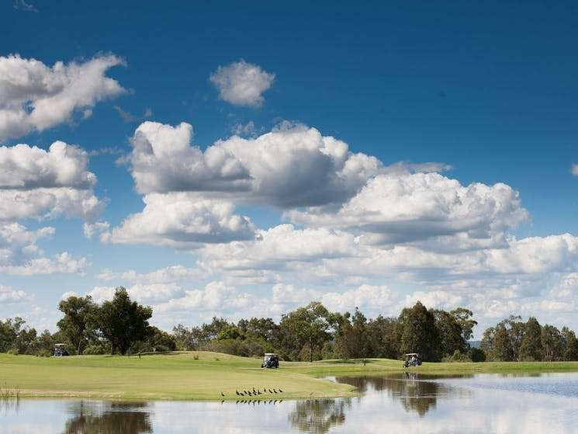

- Cypress Lakes
- Crowne Plaza – Hunter Valley Golf Club
- Stonebridge Golf Club
- Muswellbrook Golf Club

Cycling
Sutton Estate
